Year 7 Assessment Name....................................... Teacher..............................

- $\frac{3}{4}$ of this glass is full of orange juice. Mark on the glass where you think the orange juice will reach.
$\frac{1}{3}$ of this glass is full of orange juice. Mark on the glass where you think the orange juice will reach
Explain whether you can pour the second glass into the first without it overflowing

- Ribbon is sold in pieces $\frac{1}{3}$ of a metre long
How many pieces can you cut from a piece that is 4m long?
4m
0m

- How many centimetres in a metre?

- What is $\frac{3}{4}$ + $\frac{1}{2}$

Do you think you have got this right?
Explain why

- What fraction is 25c of a dollar?
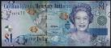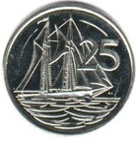

- What is 60% of 200?
100%
60%
0%

?
200
0

- Put the following numbers in order with the lowest first
2.5 2.25 2.75

- Here is a picture of the 100m Olympics in 2012

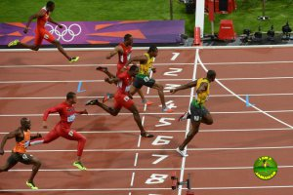

Here are the times for the first 3 in the race
Runner A 9.63 seconds Runner B 9.8 seconds Runner C 9.75
Mark on the picture to show which you think is runner A, runner B and runner C

- If 25% is 60 what is 100%
25%
0%
100%
0

60
?

- Estimate how many litres of water are there in each tank?
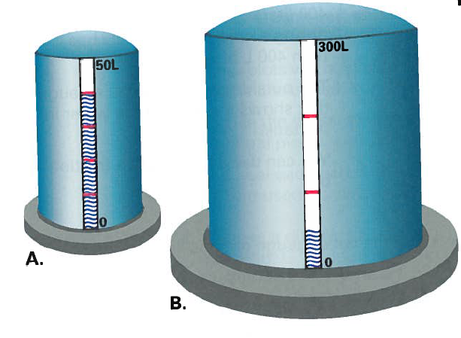
B.
A.

- Mary got 25 out of 75 in her maths test. George got 15 out of 40.

Who did best? Explain your reasoning

- What fraction of this picture is shaded? Explain how you did it

- A restaurant bill is for $150 before a tip is added. If you want to give a 20% tip how much should you pay altogether?

